PATIENT NAME |  | TODAY’S DATE
HOME ADDRESS |  | DATE OF BIRTH
 |  | HOME PHONE
 |  | CELL PHONE
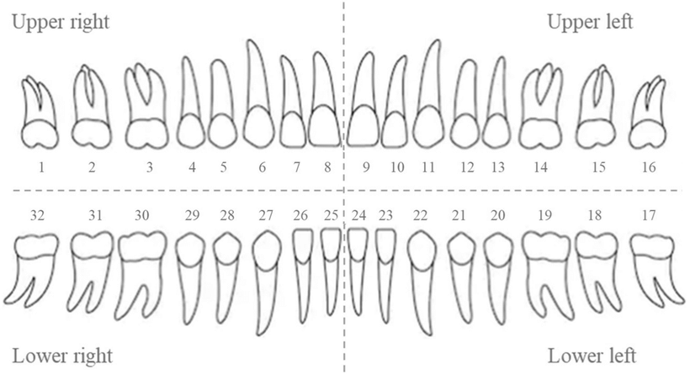
RESTORATIONS & ESTIMATE
TEETH | DESCRIPTION | FEE

